TABLES

TABLE S1: INTENSITY - ENDOMETRIAL HYPERPLASIA CASES

Intensity of PR marker in endometrial  Hyperplasia | Endometrial hyperplasia without atypia | Endometrial atypical hyperplasia | No. of cases
SCORE 0 | 0 | 0 | 0
SCORE 1 | 0 | 1 | 1
SCORE 2 | 3 | 0 | 3
SCORE 3 | 54 | 3 | 57
Total | 57 | 4 | 61

TABLE S2: INTENSITY - ENDOMETRIAL CARCINOMA CASES

Intensity of PR staining | No. of cases | Percentage
SCORE 0 | 3 | 37.5
SCORE 1 | 0 | 0
SCORE 2 | 3 | 37.5
SCORE 3 | 2 | 25
Total | 8 | 100

TABLE S3: ALLRED SCORES IN ENDOMETRIAL HYPERPLASIA CASES

Allred Score interpretation (Total Score) | Endometrial  hyperplasia without atypia | Endometrial  atypical hyperplasia | No. of cases
Negative (0-2) | 0 | 0 | 0
Very poor (3) | 1 | 1 | 2
Poor (4-5) | 4 | 0 | 4
Intermediate (6) | 10 | 0 | 10
Rich (7-8) | 42 | 3 | 45
Total | 57 | 4 | 61

TABLE S4: ALLRED SCORES IN ENDOMETRIAL CARCINOMA CASES

Allred Score Interpretation  (Total Score) | No. of cases | Percentage
Negative (0-2) | 3 | 37.5
Very poor (3) | 0 | 0
Poor (4-5) | 2 | 25
Intermediate (6) | 0 | 0
Rich (7-8) | 3 | 37.5
Total | 8 | 100

TABLE S5: COMPARISON OF ALLRED SCORES BETWEEN ENDOMETRIAL HYPERPLASIA AND ENDOMETRIAL CARCINOMA

ALLRED SCORE INTERPRETATION  (Total Score) | ENDOMETRIAL HYPERPLASIA | ENDOMETRIAL CARCINOMA | TOTAL
Negative (0-2) | 0 | 3 | 3
Very poor (3) | 2 | 0 | 2
Poor (4-5) | 4 | 2 | 6
Intermediate (6) | 10 | 0 | 10
Rich (7-8) | 45 | 3 | 48
Total | 61 | 8 | 69
*

*CHI SQUARE TEST - p = < 0.000001 (HIGHLY SIGNIFICANT)

FIGURES

FIGURE S1: DISORDERED PROLIFERATIVE ENDOMETRIUM

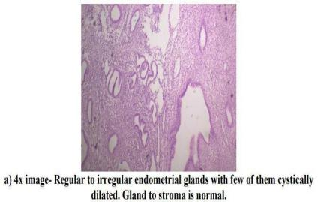

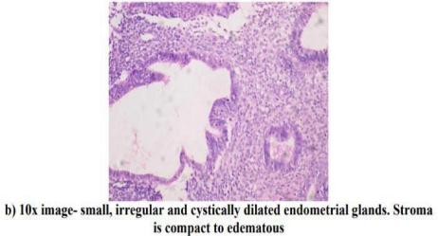

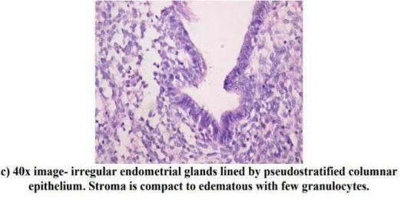

FIGURE S2: PROLIFERATIVE PHASE ENDOMETRIUM
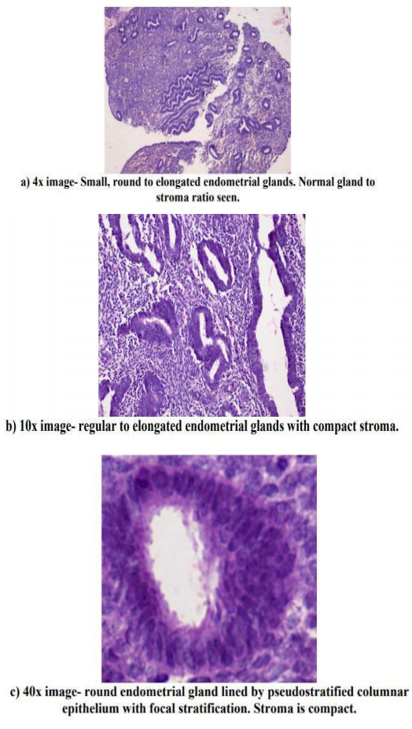

FIGURE S3: MENSTRUAL PHASE ENDOMETRIUM

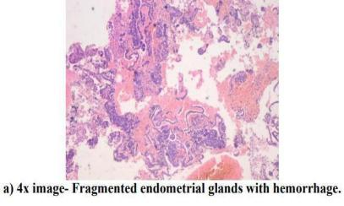

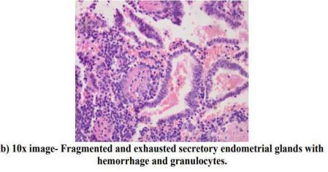

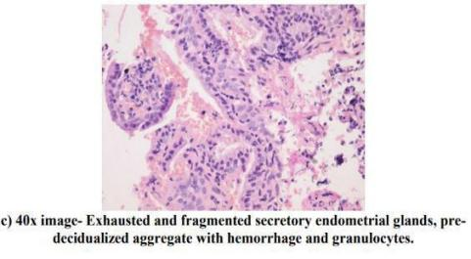

FIGURE S4: ATROPHIC ENDOMETRIUM

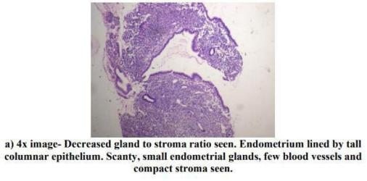

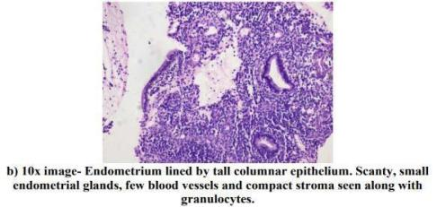

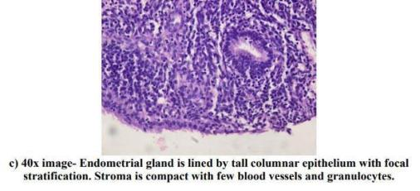

FIGURE S5: IRREGULAR SHEDDING

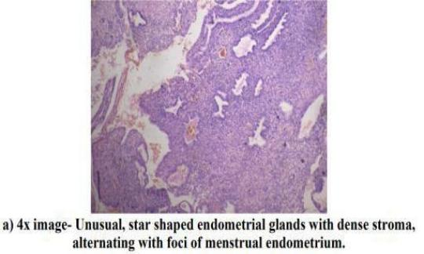
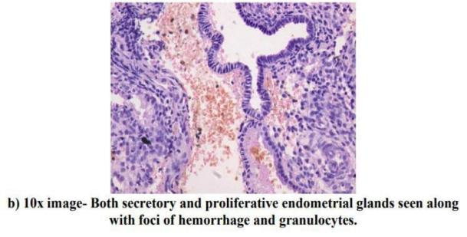
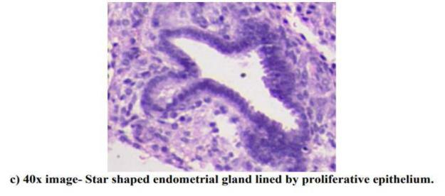

FIGURE S6: ENDOMETRIAL ATYPICAL HYPERPLASIA

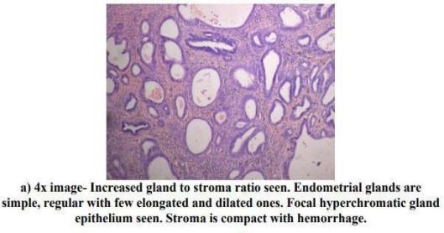

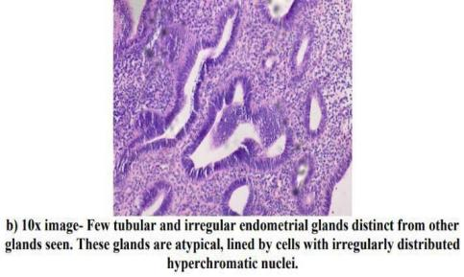

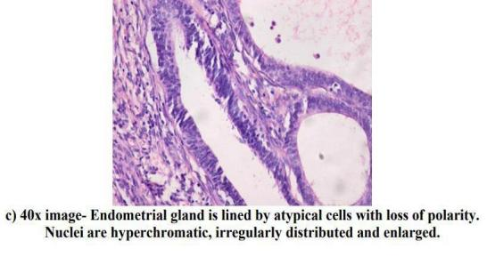

FIGURE S7: ENDOMETRIAL CARCINOMA TYPE 1

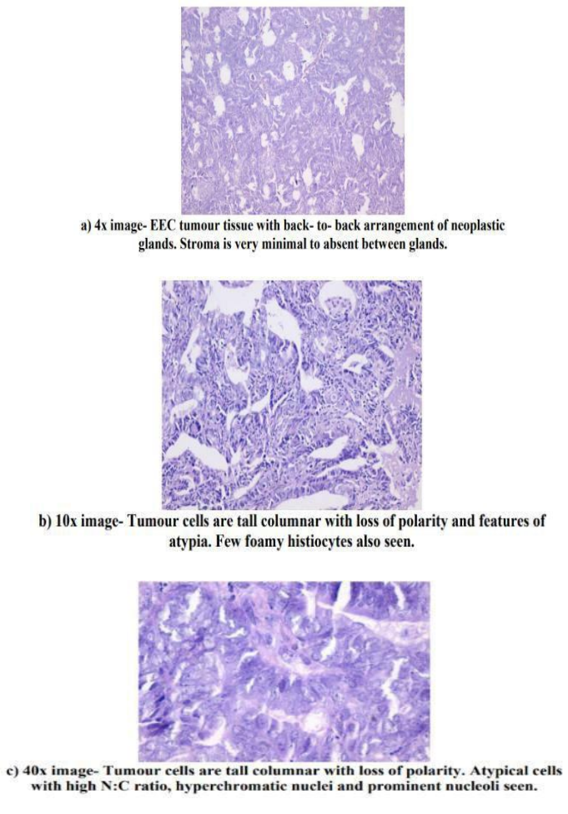

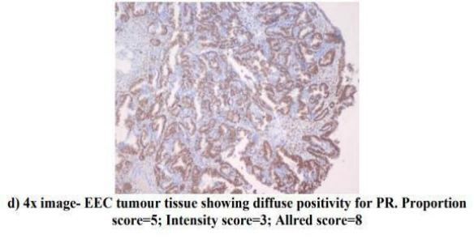

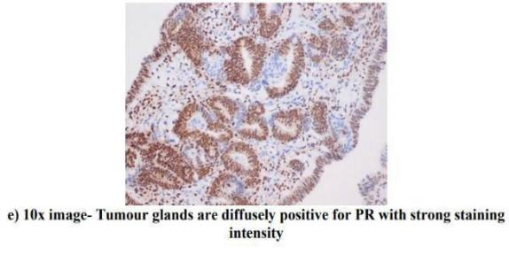
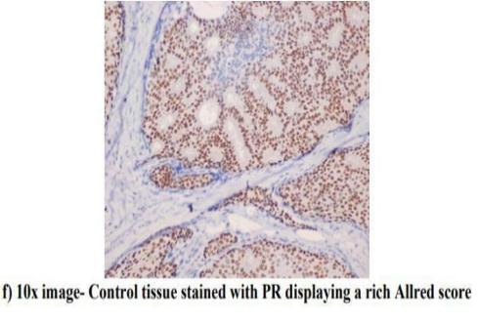

FIGURE S8: ENDOMETRIOD ENDOMETRIAL CARCINOMA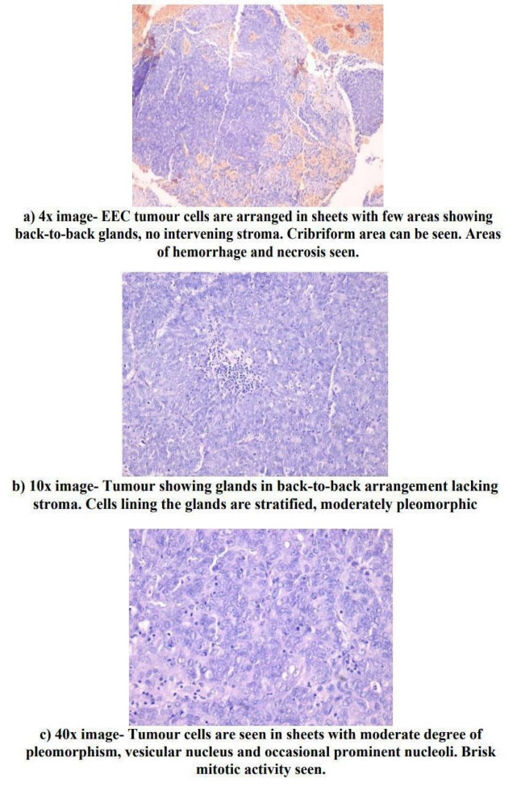
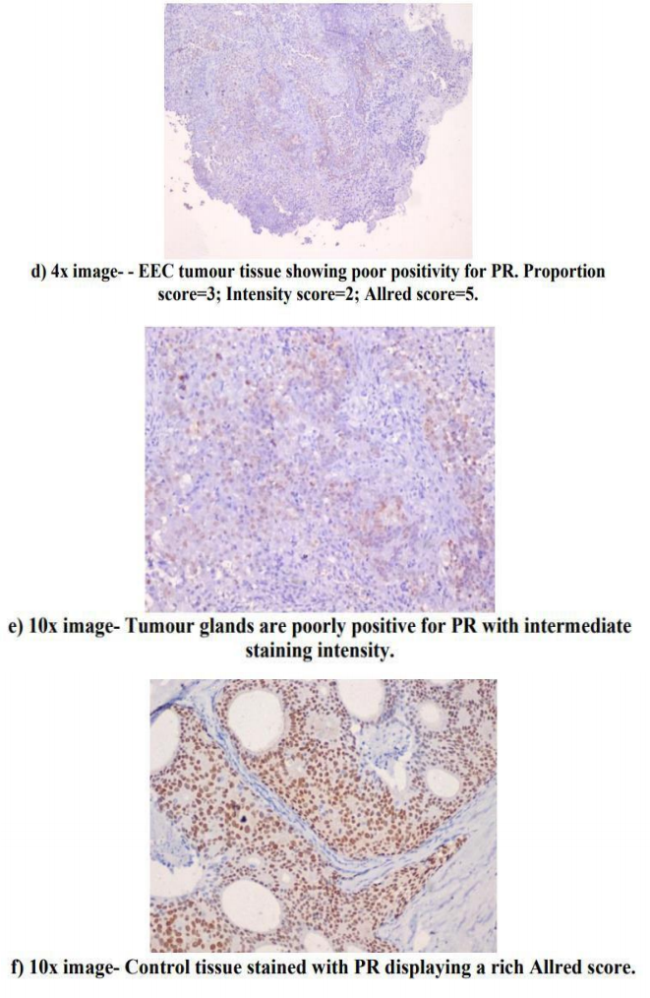

FIGURE S9: SEROUS PAPILLARY CARCINO0MA

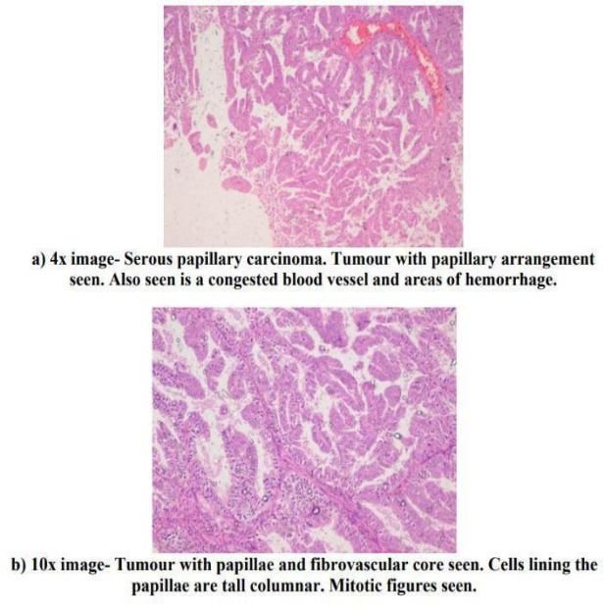

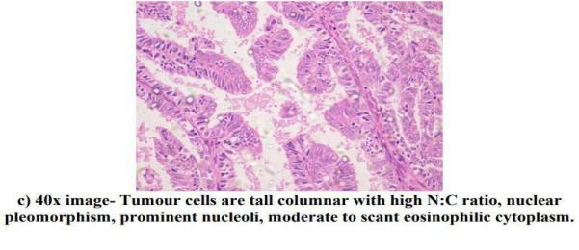

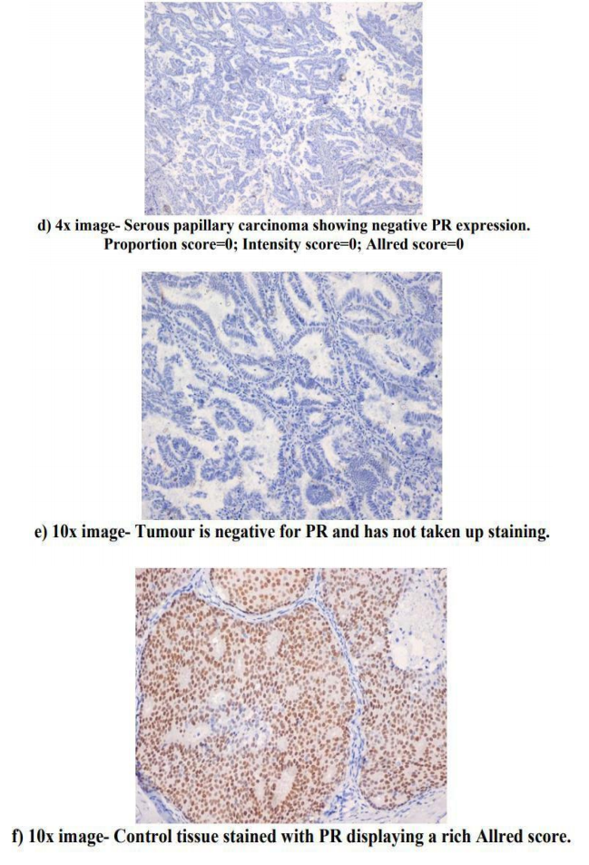

FIGURE S10: ENDOMETRIAL HYPERPLASIA WITHOUT ATYPIA - PR
EXPRESSION

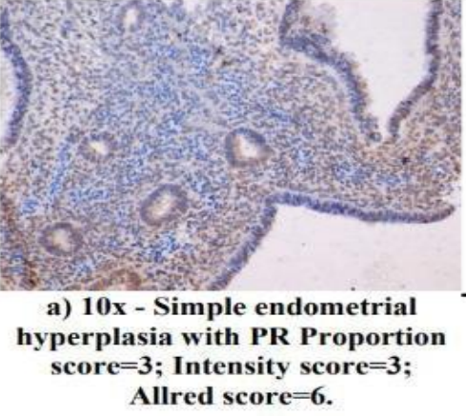

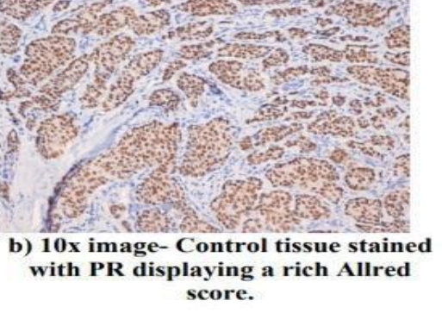

FIGURE S11 : ENDOMETRIAL ATYPICAL HYPERPLASIA - PR EXPRESSION



